GIT- Download GIT

Login to GITHUB

User id- triptinayak

Password- Mytr1pt1

Steps to push a new project to GITHUB:

1. Create a new repository in GITHUB
2. Configure the author name and email address to be used with your commits.
3. Enter in cmd

C:\Users\tript>git config --global user.name "triptinayak"

Hit enter

C:\Users\tript>git config --global user.email "tripti\_5@yahoo.com"

Hit enter

1. Goto the folder in which file is located.
2. Initialize file in Git reporsitory – git inti
3. Add all files from GITSTUFF with the cmd

C:\Users\tript\GITSTUFF>git add \*

1. Commit code to git

C:\Users\tript\GITSTUFF>git commit -m "first version”

1. Connect to GIT repo

C:\Users\tript\GITSTUFF>git remote add origin <https://github.com/triptinayak/Guru99Demo.git>

1. C:\Users\tript\GITSTUFF>git push origin master

Step to pull code from GITHUB: (first time)

1. In cmd locate the folder you want to push
2. Enter command

C:\Users\tript>git clone <https://github.com/triptinayak/Guru99Demo.git>

Get the link from GITHUB

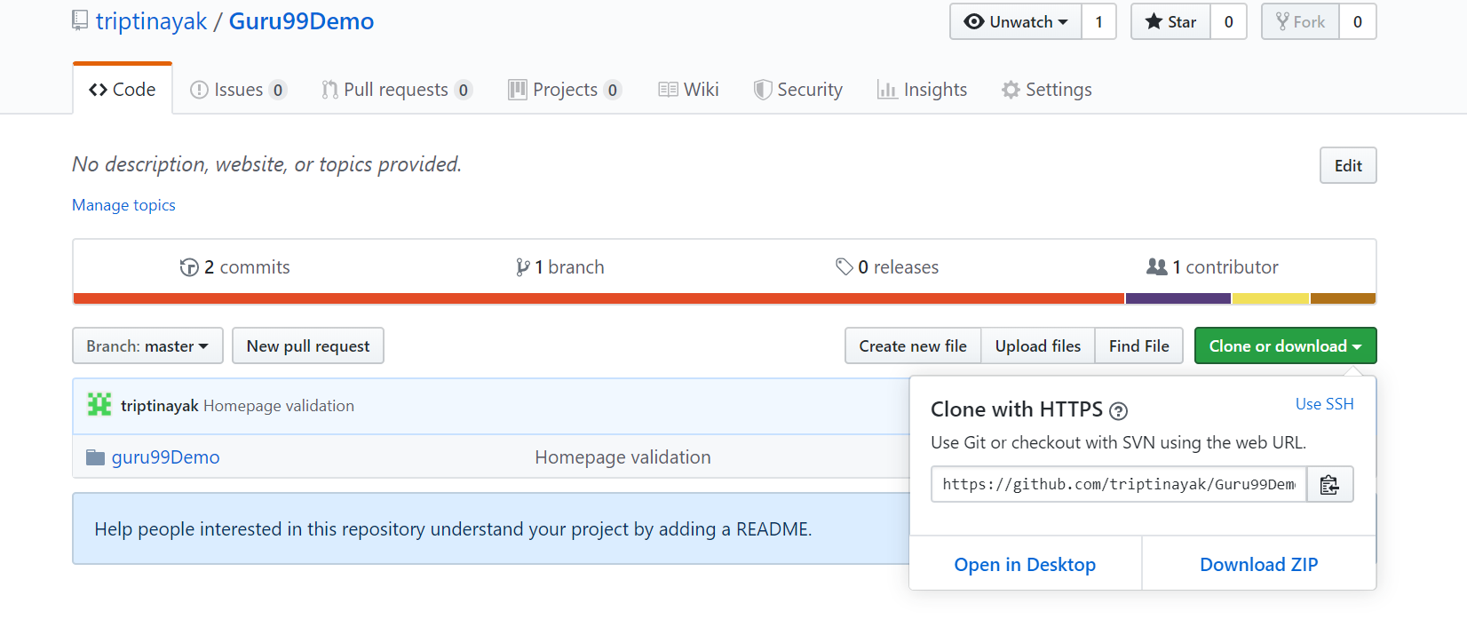

GIT PUSH for the modified code

Move code to staging

* + Git add
  + Git status
  + Git commit -m “version change”
  + Git push origin master

GIT PULL (only pull the changes from GITHUB to local)

* Git pull origin master